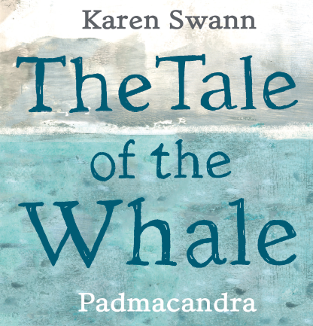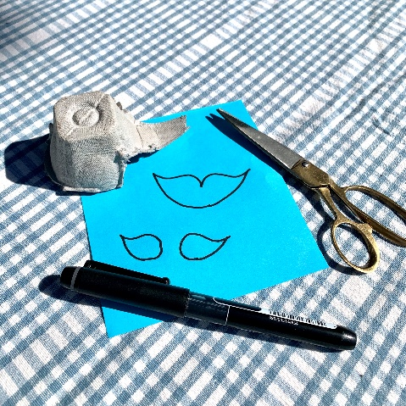

Make Your Own Eggbox Whale

**You will need:**

* **An eggbox**
* **Paper or card (blue or white to paint)**
* **Paint, paintbrush, pot**
* **Marker Pen**
* **Glue**
* **Scissors**
* **Messy apron**

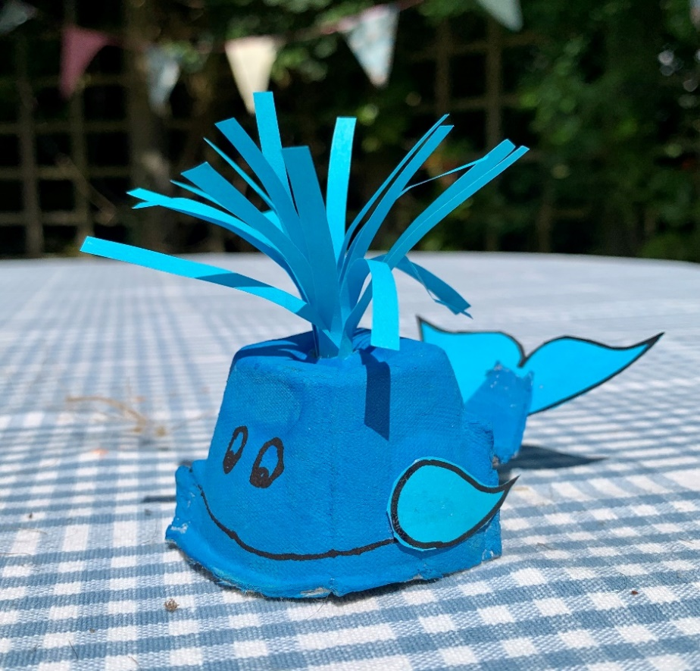

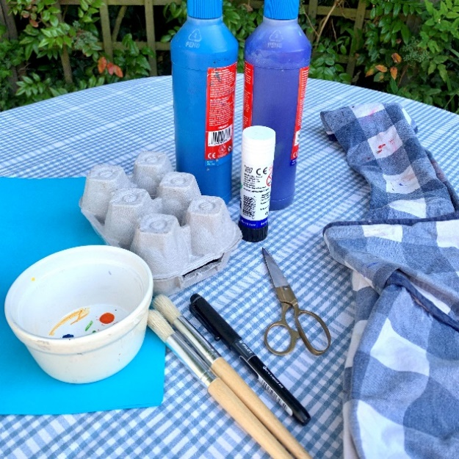

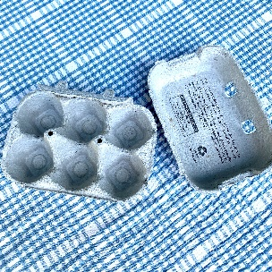

*Ask an adult to help you with scissors and cutting out*

* Cut your eggbox in half and save the lid for another project.
* Cut around a segment and include a strip from the pointy bit. This will help to make the tail of your whale.

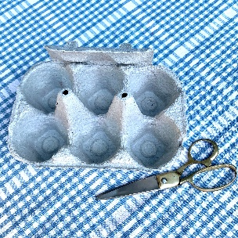

* Give your eggbox section a coat of paint and leave it to dry.
* On a piece of blue paper or card (or painted card) draw a tail fluke and two fins
* Cut them out

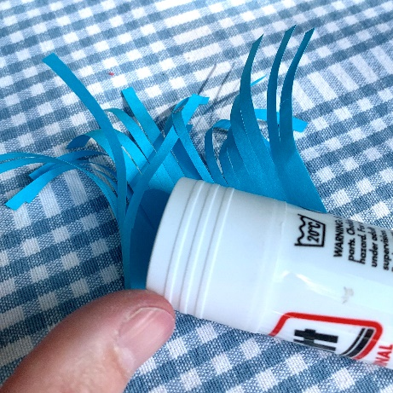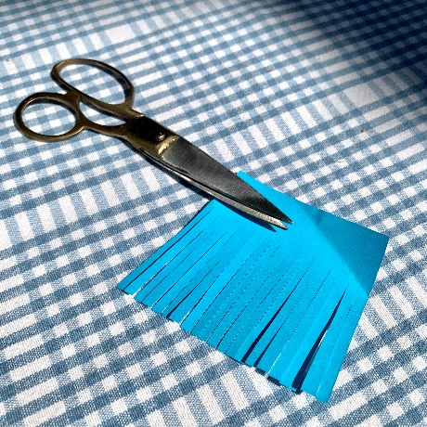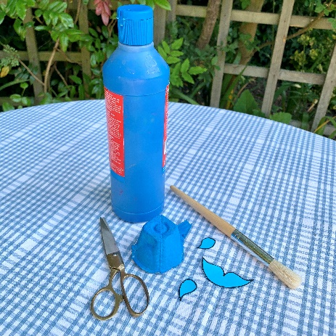

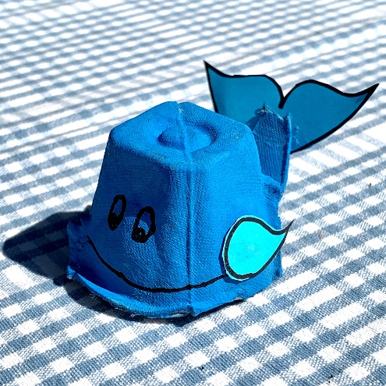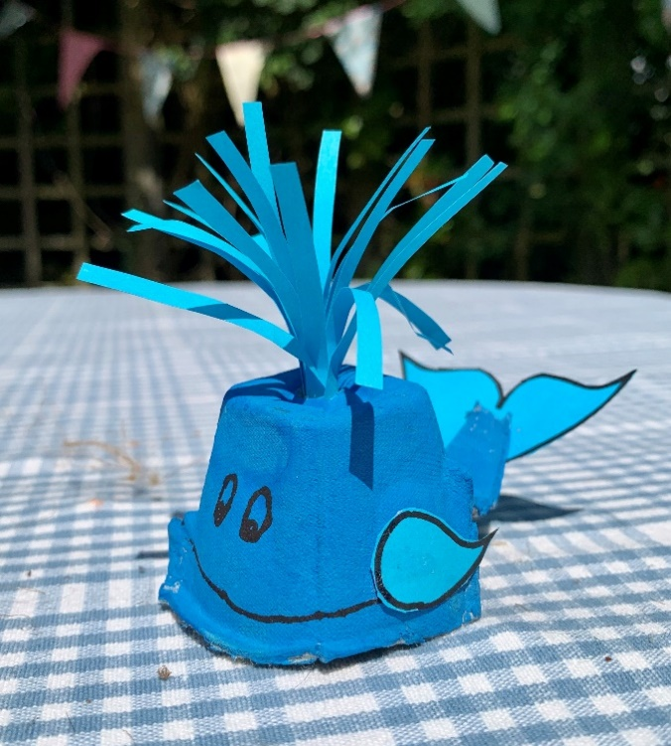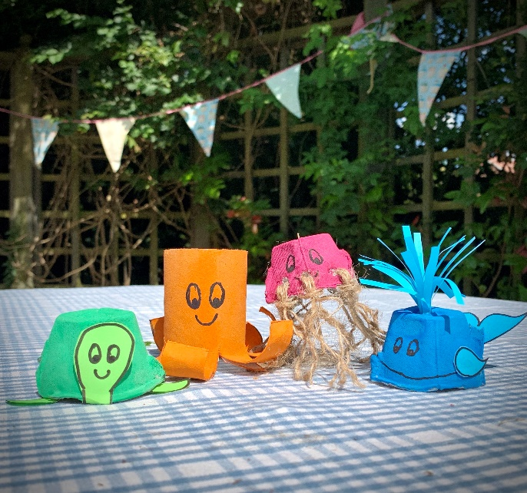

Take a look at the other eggbox and toilet roll sea-life characters you can make. You could draw or write a story about them. Have fun!

* Now you are ready to assemble your whale.
* Glue the tail fluke to the longer strip of the eggbox section
* Glue the fins to the sides of the whale
* With the marker pen, draw some eyes and a smiley face
* Take a strip of blue paper and cut small strips into it to about ¾ of the way across the width. Don’t cut right to the end.
* Roll the paper around a pen to curl it
* Glue along the uncut edge and roll lengthways to form the spout
* Make a small hole in the top of your whale
* Add your water spout
* Now, give your whale a name!