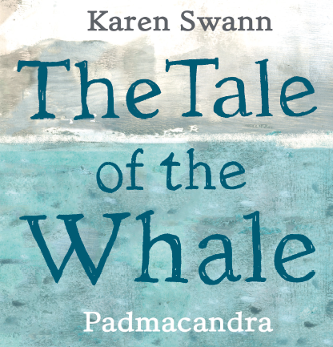

Make Your Own Eggbox Turtle

**You will need:**

* **An eggbox**
* **Paper or card (green or white to paint)**
* **Paint, paintbrush, pot**
* **Marker Pen**
* **Glue**
* **Scissors**
* **Messy apron**

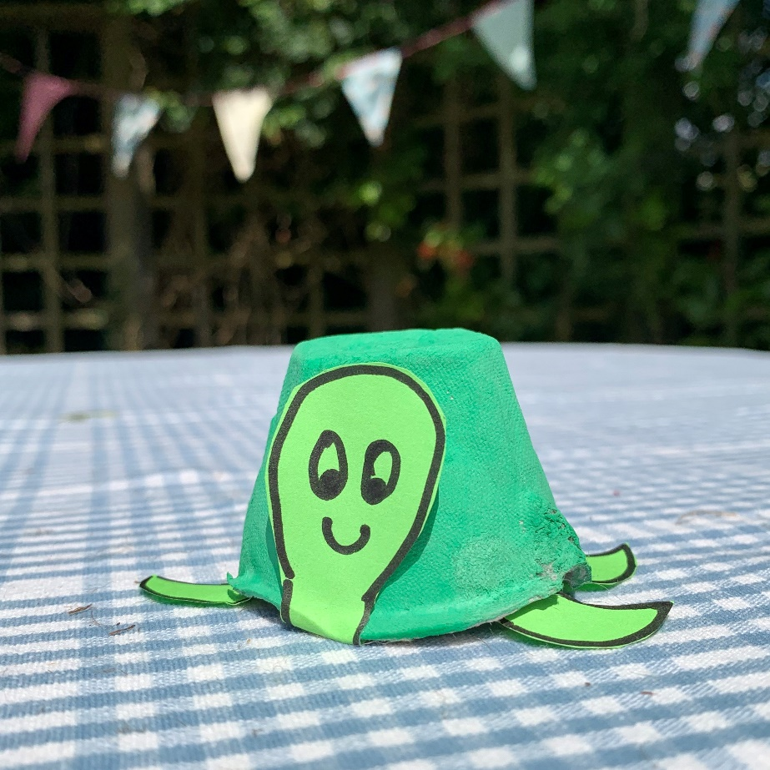

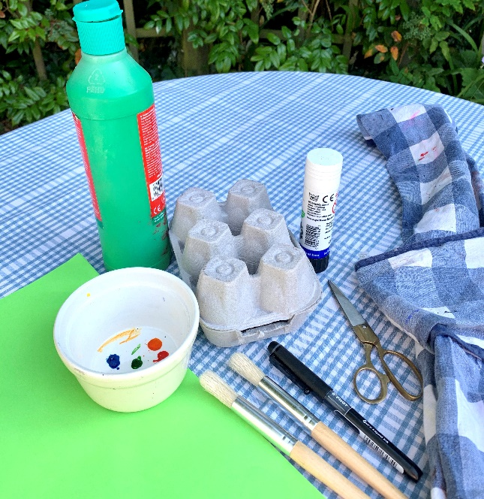

*Ask an adult to help you with scissors and cutting out*

* Cut your eggbox in half and save the lid for another project.
* Cut around a segment
* Give your eggbox section a coat of paint and leave it to dry.

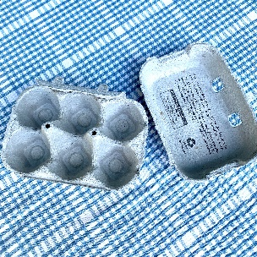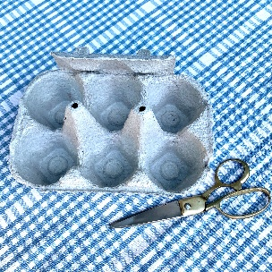

* Place your eggbox segment on a piece of paper or card and mark out the shape of the flippers (and a tail, not shown)
* Add an extra bit as a tab to give you something to attach to the eggbox segment.

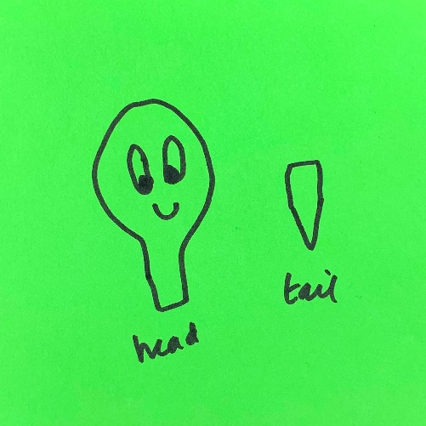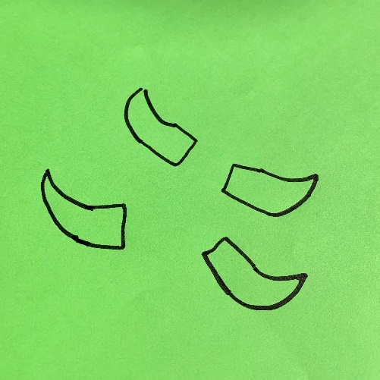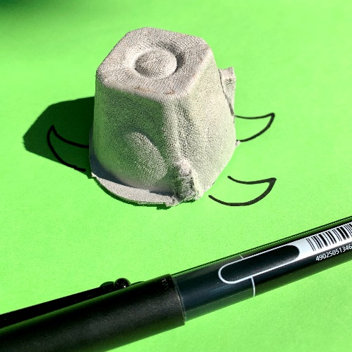

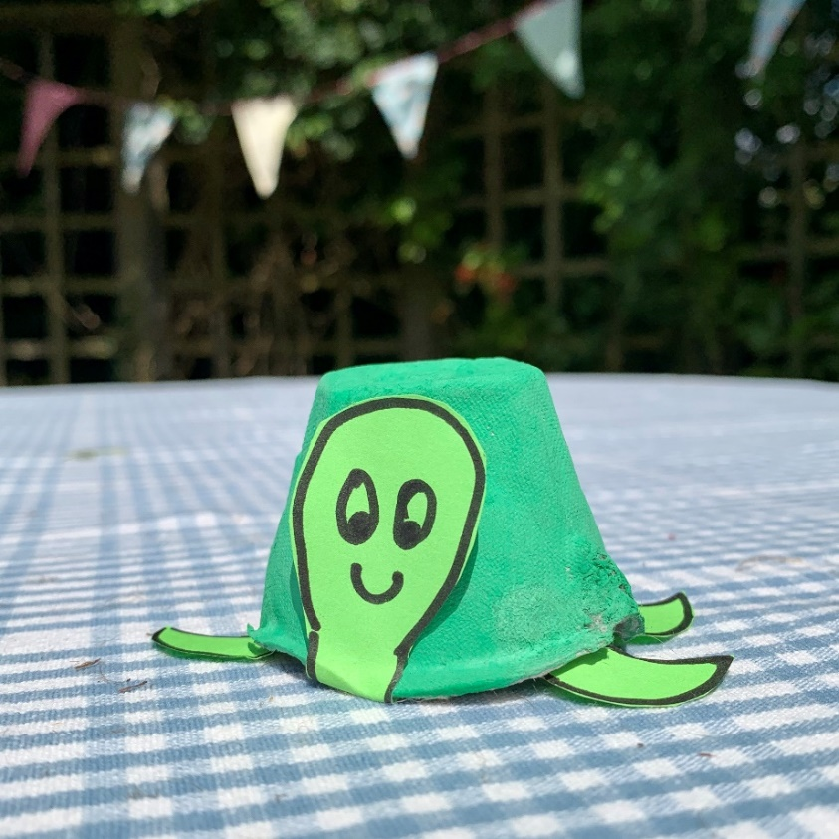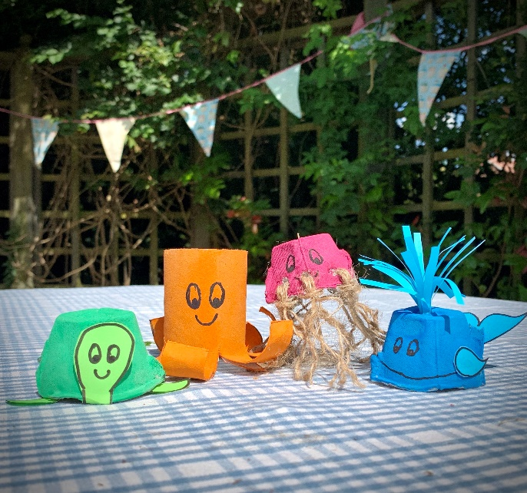

* Draw a head shape with a little tab to attach to the eggbox segment.
* Add some eyes and a smiley face!
* Cut all the pieces out
* Now you are ready to assemble your turtle.
* Glue the flippers and the tail to the inside of the eggbox segment using the tabs
* Glue the head to the front of the turtle
* Now give your turtle a name!

Take a look at the other eggbox and toilet roll sea-life characters you can make. You could draw or write a story about them. Have fun!