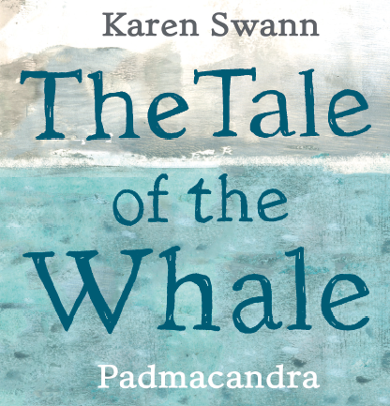

Make Your Own Toilet Roll Octopus

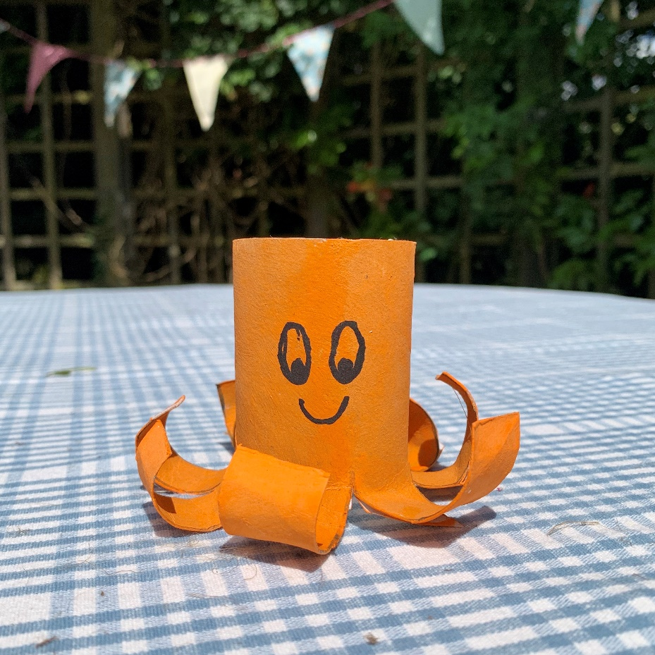

**You will need:**

* **A toilet roll inner**
* **Paint, paintbrush, pot**
* **Marker Pen**
* **Scissors**
* **Messy apron**

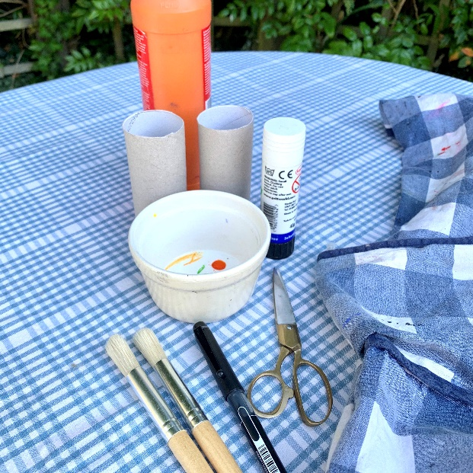

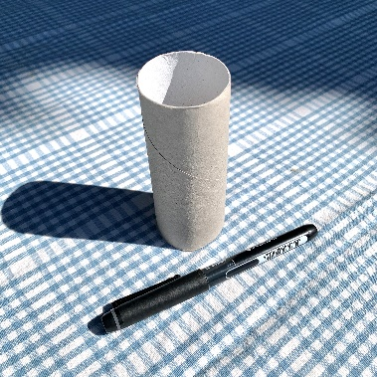

*Ask an adult to help you with scissors and cutting out*

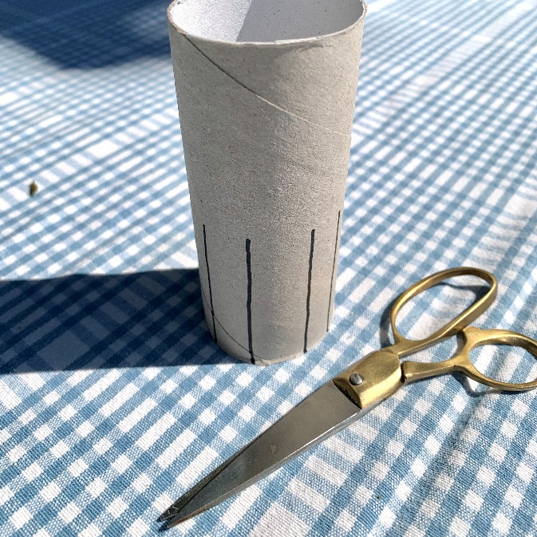

* From halfway down the toilet roll inner, use the maker pen, to divide the toilet roll inner into eight strips
* To space them evenly. it helps if you draw one line then the next the opposite side of the toilet roll inner.
* Then draw the next line in between the two and the next opposite that etc.

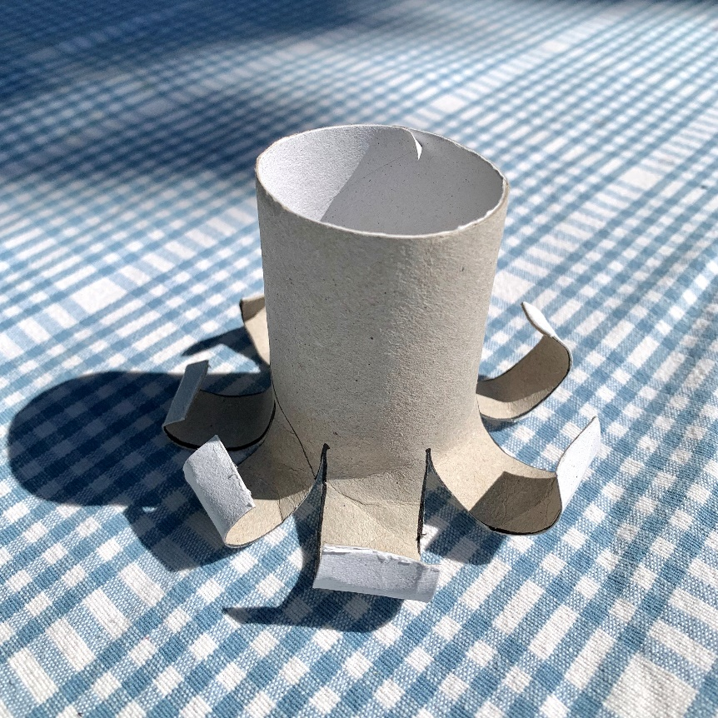

* Cut along each line to divide the bottom half of the toilet roll inner into eight tentacles
* Roll up each tentacle around a pencil to make it curl.
* If necessary, bend it further by hand.

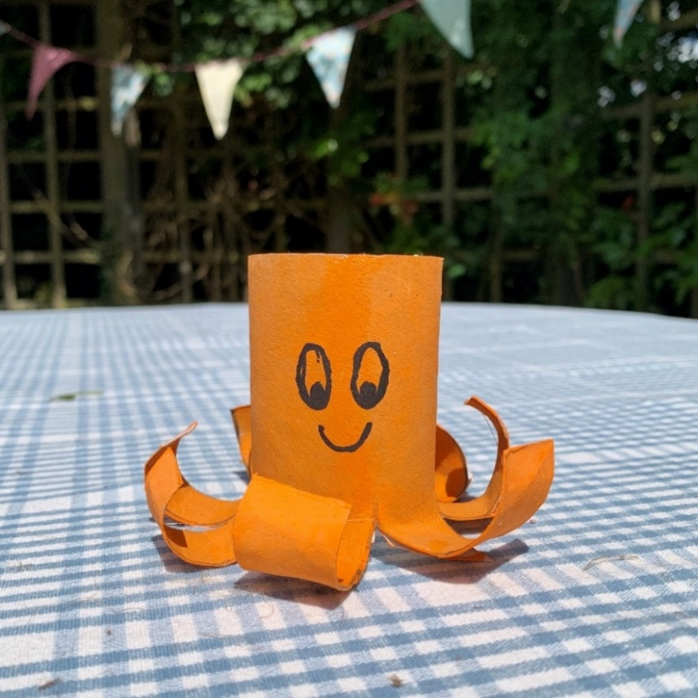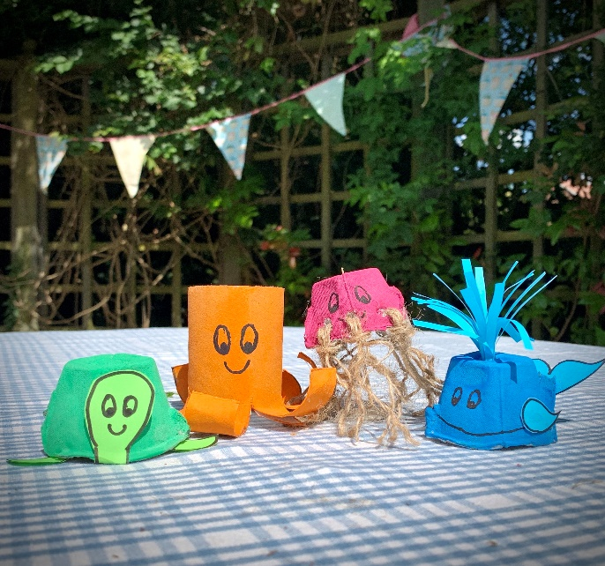

Take a look at the other eggbox and toilet roll sea-life characters you can make. You could draw or write a story about them. Have fun!

* Give your octopus a coat of paint and leave it to dry. Don’t forget the bottom edges of the tentacles – you will see them!
* With the marker pen, draw some eyes and a smiley face
* Now, give your octopus a name!