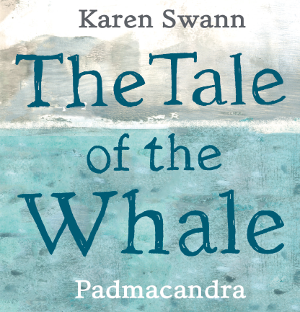

Make Your Own Eggbox Jellyfish

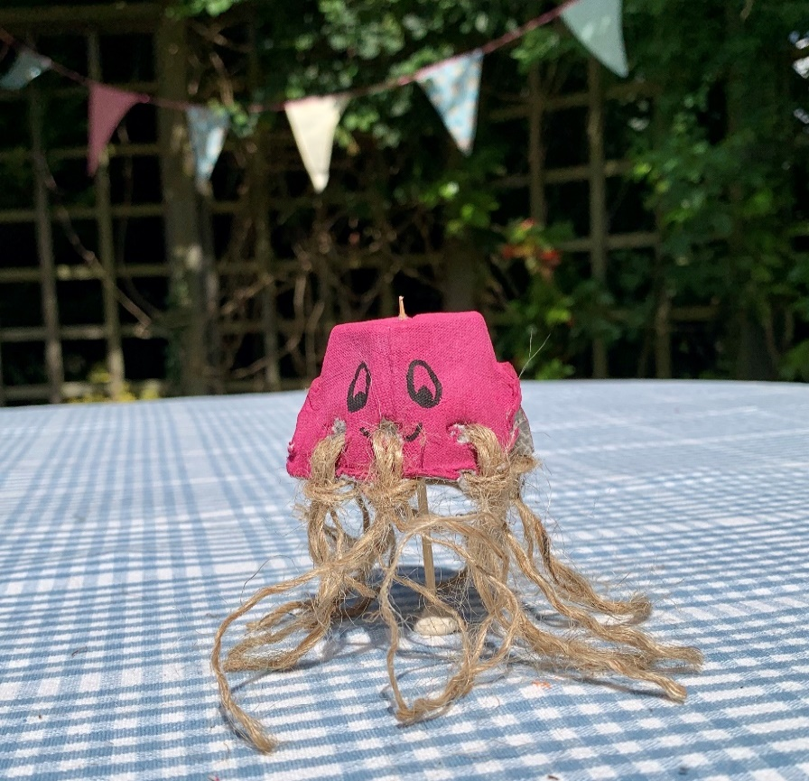

**You will need:**

* **An eggbox**
* **Some string, wool or twine**
* **Paint, paintbrush, pot**
* **Marker Pen**
* **Scissors**
* **Messy apron**

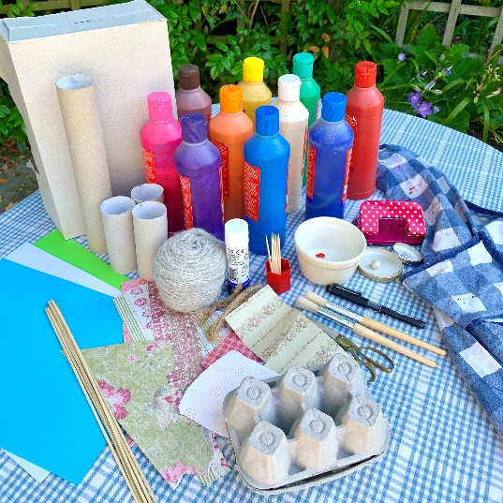

*Ask an adult to help you with scissors and cutting out*

* Cut your eggbox in half and save the lid for another project.
* Cut around a segment
* With an adult’s help, make some holes all along the bottom edge of your eggbox segment with a pair of scissors.

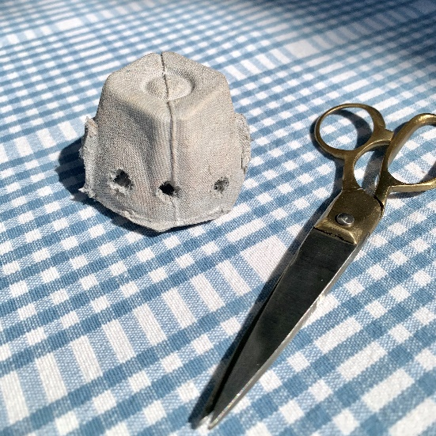

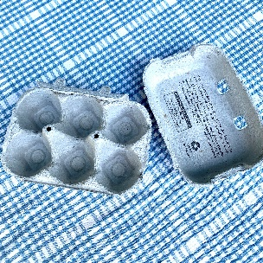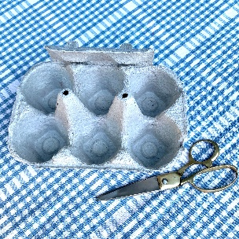

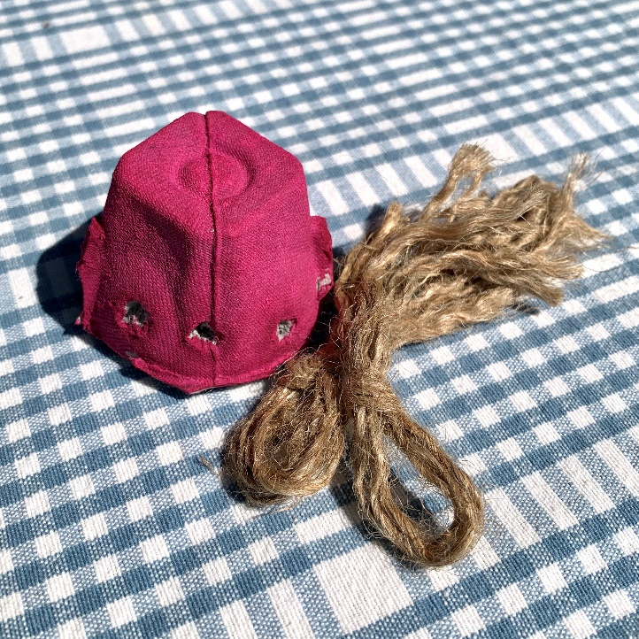

* Paint the eggbox segment and set aside to dry
* Meanwhile, cut some pieces of string / wool or twine into little strips
* Now you are ready to assemble your jellyfish
* Fold the piece of string or wool in half and poke it through one of the holes

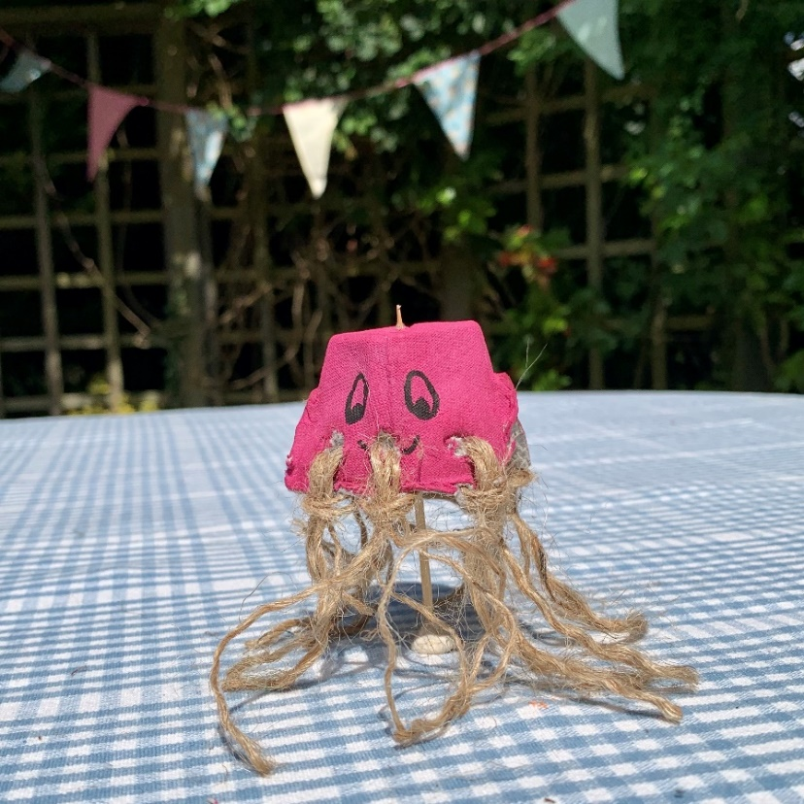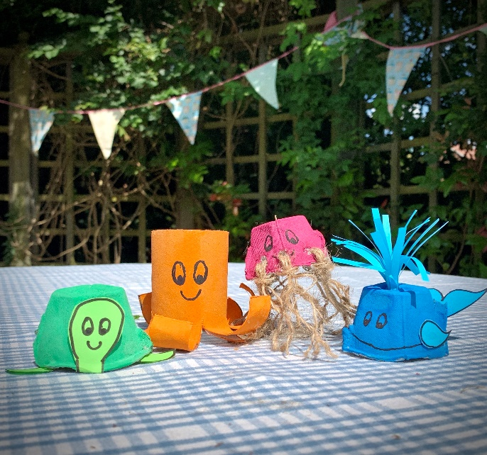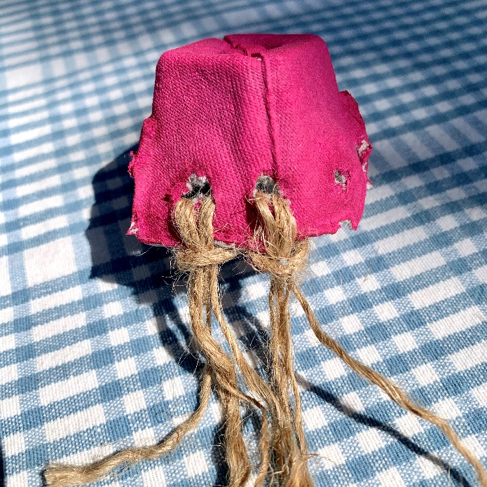

* Feed the ends of the string through the loop and pull tight
* Repeat with all the holes / string
* With the marker pen, draw some eyes and a smiley face

Take a look at the other eggbox and toilet roll sea-life characters you can make. You could draw or write a story about them. Have fun!

* Now, give your jellyfish a name!