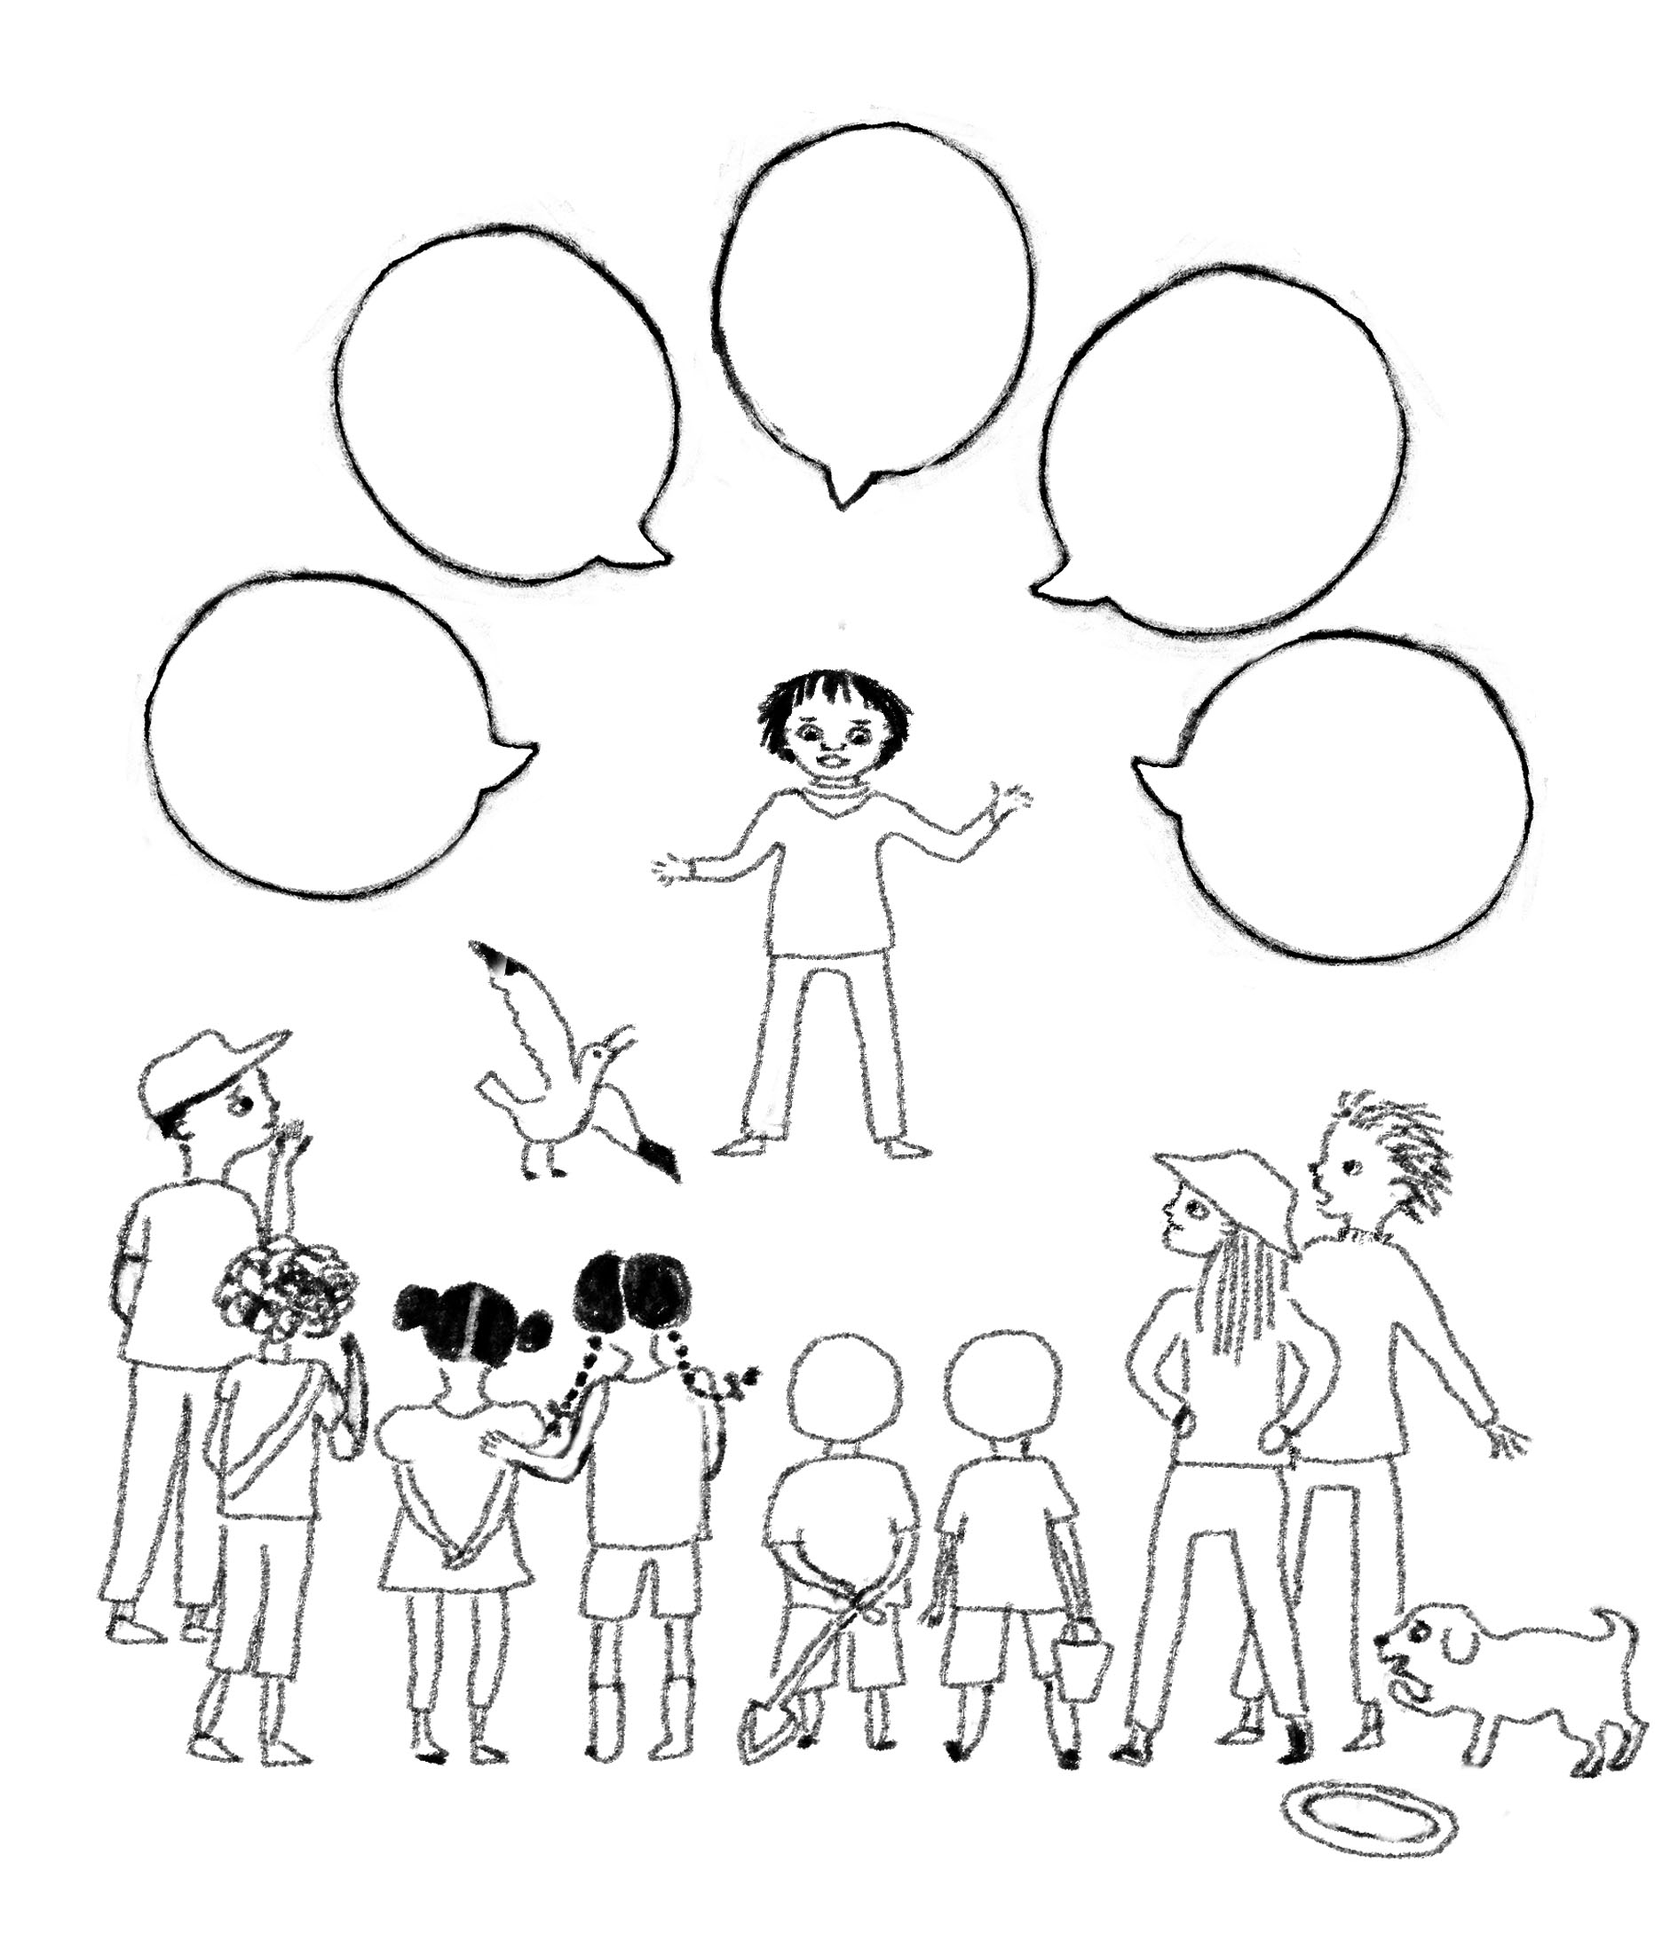
How would you help to change the whale’s story? What would you say to others? Write it in the speech bubbles and colour the picture in.

